Project Deliverable 4
PCB Layout design-part I
Semester | : | Spring | Year | : | 2026
Course Title | : | Electronic System Design + Lab
Course Code | : | ECET297
Instructor(s) | :
(Includes names of all instructors teaching this course) | :
Submission Date | :
To be completed by the student
Student Names | :
Student IDs | : |  | Department | :
Major | : |  | Section | :
Integrity Statement | : | “I affirm that I completed my assignment on my own abiding by the rules in ACM Student Handbook. I did not receive any external help, use any unlawful resources or commit plagiarism.”
Signature | :

Grading Scheme
Question | Earned Points | Max. Points | Question | Earned Points | Max. Points
1 |  | 60 | 6
2 |  | 40 | 7
3 |  |  | 8
4 |  |  | 9
5 |  |  | 10

Total Earned Points | Total Available Points | Instructor Name
 | 100
Important Notes:
- Any attempt at plagiarism will be reported. All ACM handbook academic misconduct rules will be applied.
- It is the responsibility of the student to submit this online exam paper to the instructed online platform (Moodle, Turnitin)

ECET297 – Capstone Project

Smart irrigation system using Moisture sensor and IC-741

This project involves the design and development of a smart irrigation system to monitor soil conditions and activate a water pump when the soil moisture falls below a specific threshold. The circuit is used to create an efficient solution for watering plants, by ensuring that the water pump is only activated when the soil becomes dry.

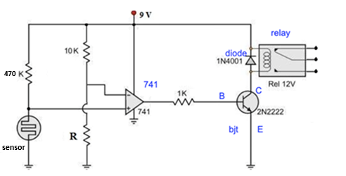

Project Deliverable 4
PCB Layout design-part I

- Pads and Footprints dimensions (60 pts-3 pts each)

  - Fill the missing cells of the below table with the correct drill and pad sizes for each component to be used in the project based on the product No.

SN. | Product No. | Component |  | Pads Dimensions (mm)
SN. | Product No. |  |  | Drill size | Pad Size
1 | 1935161 | wire to board connector used for sensor and battery | Circle / Square | 1.30 mm | 2.50 mm
2 | CF14JT1K00TR-ND | Resistors | Circle | 0.80 mm | 1.60 mm
3 | 365-1183-ND | LED | Circle / Square | 0.90 mm | 1.80 mm
4 | LM741CNNS/NOPB-ND | Op-amp | Circle / Square | 0.80 mm | 1.60 mm

  - Fill the below table with the correct Footprint dimensions for each component to be used in the project based on the product No.

SN. | Product No. | Component | Footprint Dimensions
SN. | Product No. | Component | D | E | e1/e
1 | 1935161 | wire to board connector used for sensor and battery | 9.00 mm | 8.30 mm | 5.00 mm
2 | CF14JT1K00TR-ND | Resistors | 6 mm | 2.30 mm | 7.62 mm
3 | 365-1183-ND | LED | 5.00 mm | 2.54 mm | 2.54 mm
4 | LM741CNNS/NOPB-ND | Op-amp | 9.27 mm | 6.35 mm | e = 2.54 mm  e1 = 7.62 mm

- Footprints design using easyeda (40 pts-10 pts each)
  - Design the Footprint of the Wire to Board connector, take screenshot of the dimensions

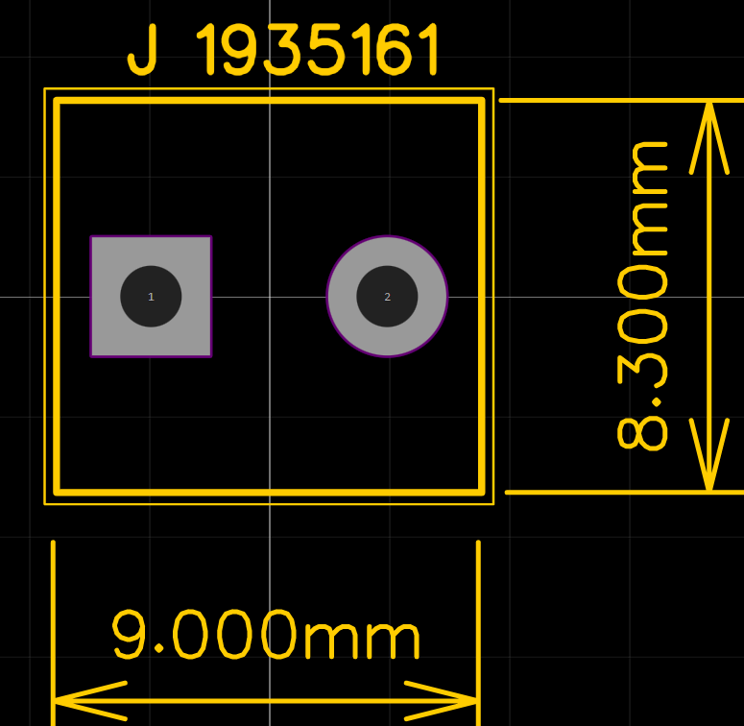

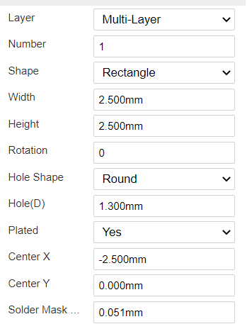

  - Design the Footprint of the Resistor, take screenshot of the dimensions

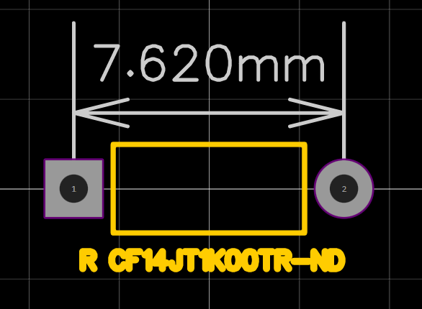

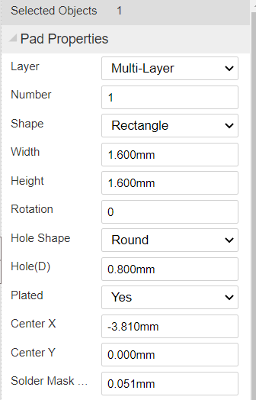

  - Design the Footprint of the LED, take screenshot of the dimensions

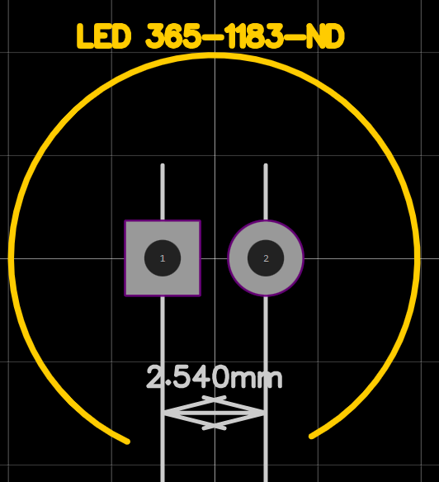
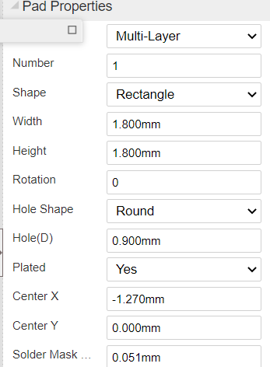

  - Design the Footprint of the Opamp, take screenshot of the dimensions



